**Supplementary Materials**

**Result**

**Reproducibility of ECG traits and brain IDPs**

To validate the measurement robustness of the 168 ECG traits and 2,142 brain IDPs, we first examined their test-retest reproducibility using the repeat imaging visit (n=1,940 for ECG traits and n=1,294-4,685 for IDPs; average interval between visits=5 years). For each trait, we calculated the intraclass correlation coefficient (ICC) between two observations from all revisited individuals. ECG traits demonstrated moderate reproducibility (mean ICC=0.490, range=0.086 - 0.890; Supplementary Table S5), whereas brain IDPs showed substantially higher consistency overall (mean ICC=0.817, range=0.040-0.989; Supplementary Table S6). Detailed examination of ECG traits within the same waveform characteristics group showed different reliability – the amplitude related measurements of waves exhibited moderate reproducibility (mean ICC=0.624), while inter-wave intervals displayed poorer consistency (mean ICC=0.322; Supplementary Fig. S2). Notably, 38.3% (820/2142) of brain IDPs demonstrated exceptional reliability (ICC>0.9), though IDPs from task functional brain MRI (mean=0.307) showed poor reproducibility in revisiting. After excluding traits with upper 95%CI < 0.5 or being zero in all samples, we retained 95 ECG traits and 2095 brain IDPs for subsequent analyses. These results indicate that the ECG traits and brain IDPs possess moderate-to-high test-retest reliability, effectively capturing biologically variations in cardiovascular and neurophysiological characteristics.

**Phenotypic correlations between ECG traits and brain IDPs**

The correlations between the ECG traits and brain IDPs were investigated using pairwise linear regression models adjusted for covariates (see Methods). Totally, 4,276 ECG trait-IDP pairs were identified as significantly [*P* < 2.51×10-7, 0.05/(2,095×95)] correlated (Supplementary Table S7). Notably, 87.46% (3,740/4,276) of theses correlations are positive, and nearly half of these correlations (46.90%, 2,001/4,276) are between the ECG traits and the IDPs of white matter (Supplementary Fig.S3), particularly telencephalic white matter (Fig.2B and Supplementary Table S8).

The regression analyses using IDPs as predictors have also been performed and yielded identical 4,276 significant associations. Comparing to the correlations obtained in regression analyses using ECG traits as predictors, these analyses have shown lower R² values (Supplementary Fig. S4), suggesting greater explanatory power of ECG traits on brain IDPs.

**Multivariate correlation analysis between ECG traits and brain IDPs**

For two classes of ECG traits, ECG lead grouping and waveform characteristics, we also performed canonical correlation analysis (CCA) to explore the multivariate associations between ECG traits groups and brain IDP groups. Prior to CCA, we assessed intraclass correlation coefficients (ICCs) for two classification schemes: 1) ECG lead grouping vs. waveform characteristics for ETCs, and 2) neuroanatomical regions vs. measurement types for IDPs. Based on ICC evaluations (Supplementary Table S9-S10) and biological interpretability, ECG traits were classified into 14 waveform characteristic categories while IDPs were grouped into 14 anatomical brain regions. The CCA patterns were consistent with those in our univariate analysis. Several ECG groups, particularly R-S amplitude difference, R-wave amplitude, S-wave peak area, S-T amplitude difference, and R-wave peak area, demonstrated broad associations with various brain region (except for basal forebrain, Fig. 2C). White matter-related IDPs showed strongest correlations with ECG waveform characteristics. The largest CCA component emerged between the R-S amplitude difference and white matter (correlation = 0.44, *P* < 5 × 10-324). Additionally, IDPs in frontal lobe and limbic lobe exhibited strong correlations with ECG traits. Sex-stratified analysis revealed comparable association patterns between males and females (Fig. 3D, Supplementary Fig S6), though males showed marginally stronger ECG-IDP correlations (mean r=0.2116 vs. 0.1914 in females).

**Heritability of ECG traits and brain IDPs**

The mean heritability (*h2*) was 11.02% for 95 ECG traits (ranging from 2.33-19.19%, Supplementary Table S12) and 19.91% for 2,095 brain IDPs (range: 3.51-40.69%, Supplementary Table S13). Among these ECG traits, the *h2* values for the voltage differences between the R-wave start and S-wave end in leads I, aVR, aVL, and V6 exceeded 18%. For brain IDPs, the volumes of medulla, pons and whole brainstem exhibited the highest heritability, with *h²* values surpassing 40%. Collectively, these findings demonstrate that ECG traits exhibit lower heritability compared to brain IDPs.

**Genetic correlations of ECG traits and brain IDPs with brain disorders and heart diseases**

We investigated genetic correlations between 95 ECG traits and 10 brain disorders, as well as between 2,095 brain IDPs and 11 heart diseases (Supplementary Table S15-16). R-wave related ECG traits have shown the highest number of significant (*P* < 5.26 × 10-4; 95 tests for ECG-brain disease) correlations with the brain IDPs (Supplementary Fig S10A). Specifically, R-wave peak area (inteR) and amplitude of R-wave (R) are found genetically correlated (*P* < 5.26 × 10-4; 95 tests for ECG-brain disease) with sleep apnoea (Supplementary Fig S10A). Out of the brain IDPs, the IDPs of white matter are more likely to be significantly correlated with heart diseases (Supplementary Fig S10B).

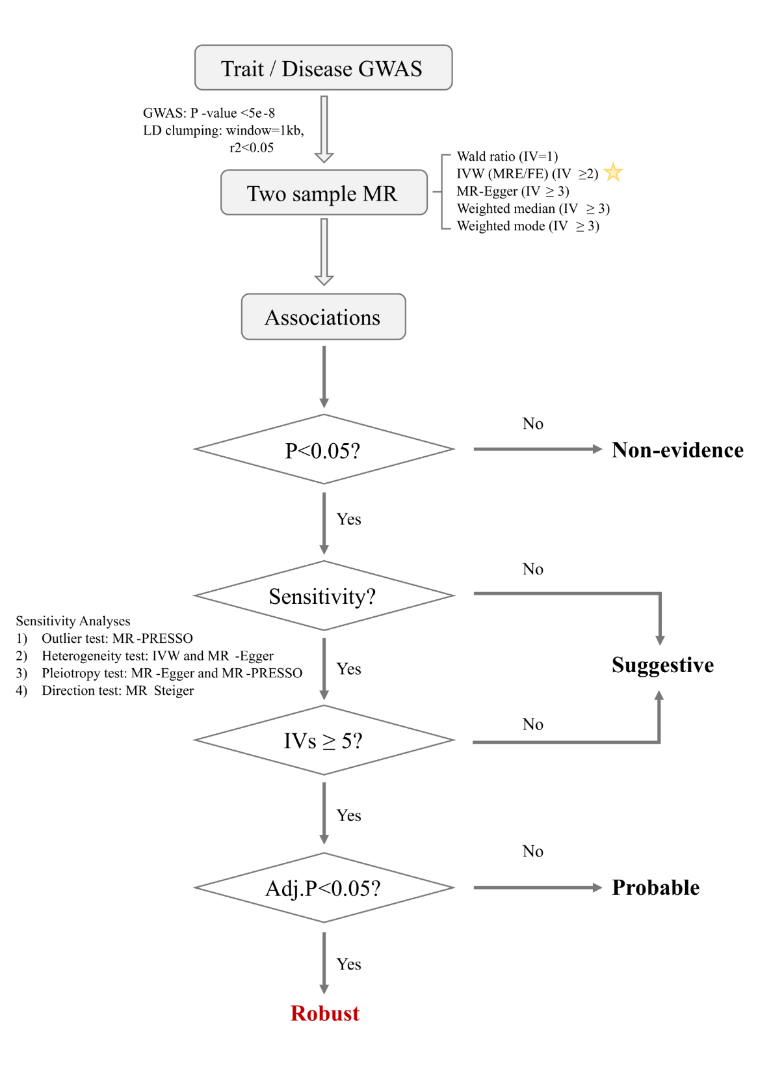

**Supplementary Fig. S1 Hierarchical classification for causal relationships**

The genetic variants in GWAS summary data were selected at a significance level of 5 × 10-8. Independent variants were retained using strict linkage disequilibrium criteria (r² < 0.05, window size = 1,000 kb) based on the 1000 Genomes European reference panel. We apply five common MR methods (Wald ratio, IVW, MR-Egger, weighted median and weighted mode) to address different forms of pleiotropic effects. We also implemented a series of sensitivity analyses to assess the robustness of MR estimation. To categorize potential causality between traits and diseases, four levels of statistical significance were established : (1) robust causality, which is defined as any MR analysis for a trait-disease pair that is significant after Bonferroni correction with ≥ 5 genetic variants and passing all four sensitivity tests; (2) probable causality meeting nominal significance (*P* < 0.05) in MR analysis using ≥ 5 genetic instruments and passing all sensitivity test, but not surviving Bonferroni correction; (3) the suggestive causality is defined as nominally significant associations (*P* < 0.05) that either failed in sensitivity test or performing MR using less than 5 genetic instruments; (4) those with a P-value greater than 0.05 were classified as non-evidence.

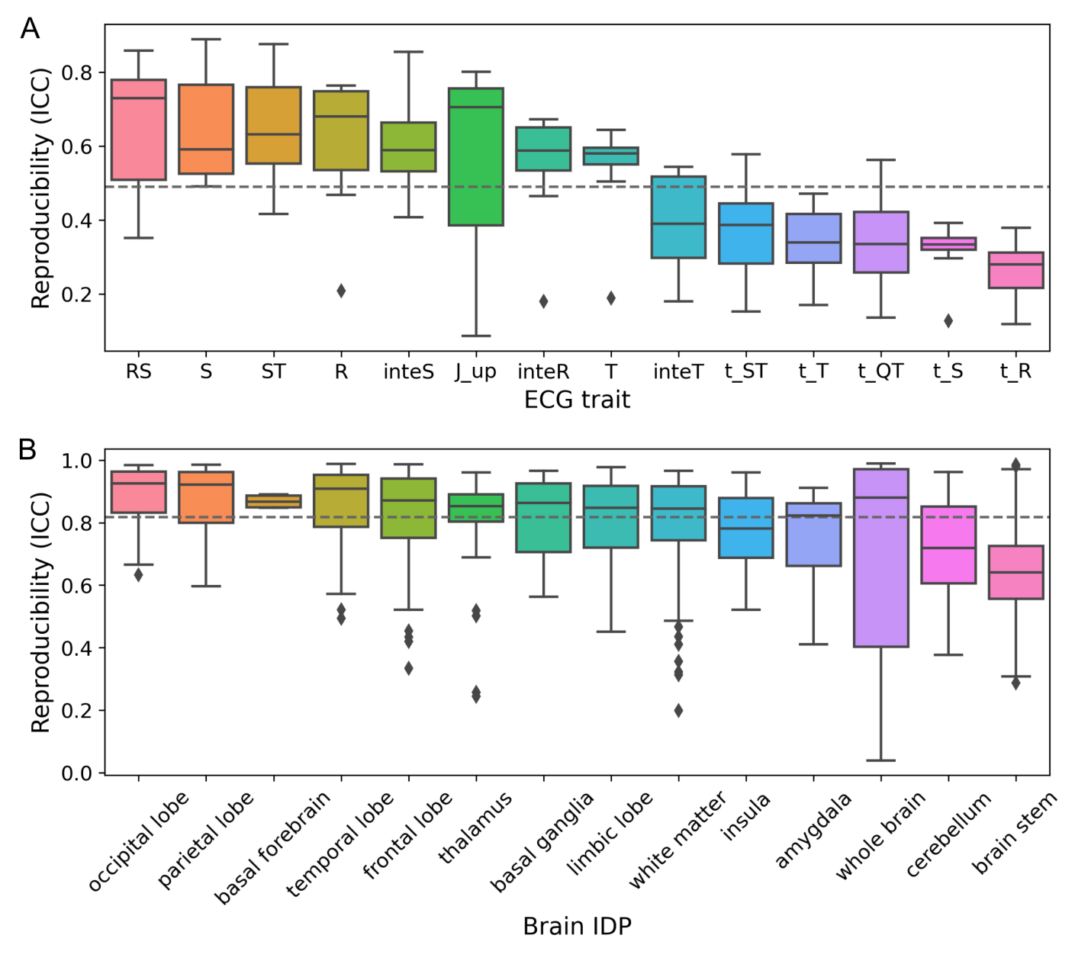

**Supplementary Fig. S2** **Reproducibility of ECG traits and brain IDPs**

The robustness of 168 ECG traits and 2,142 brain IDPs were evaluated using intraclass correlation coefficient (ICC). (A) Boxplot illustrated the reproducibility of ECG traits across different waveform characteristic types, with an overall mean ICC of 0.490. (B) Boxplot illustrated the reproducibility of brain IDPs categorized by neuroanatomical groups, showing a higher mean ICC of 0.817 across all IDPs. In both panels, the dashed lines indicated the mean value of ICC, and x-axis labels were sorted by the mean ICC of each box.

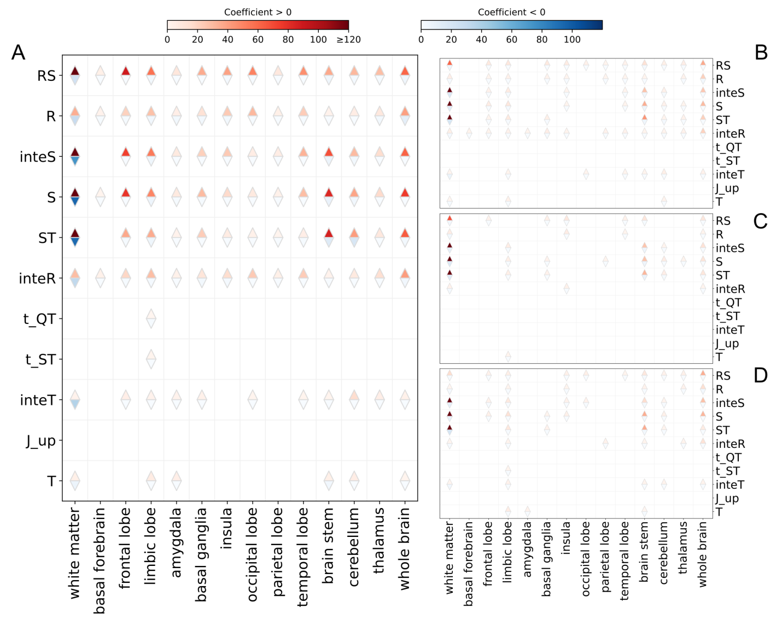

**Supplementary Fig. S3 Phenotypic correlations of ECG traits and brain IDPs**

1. All significant phenotypic correlations between the ECG traits and the brain IDPs (n=4,276) identified by pairwise linear regression analysis. (B) Significant phenotypic correlations validated in any validation sets (n=1,119). (C) Significant phenotypic correlations in female subset (n=918). (D) Significant phenotypic correlations in male subset (n=839). The color intensity of triangles corresponds to the number of significant associations, with red hues denoting positive correlations and blue hues representing negative correlations.

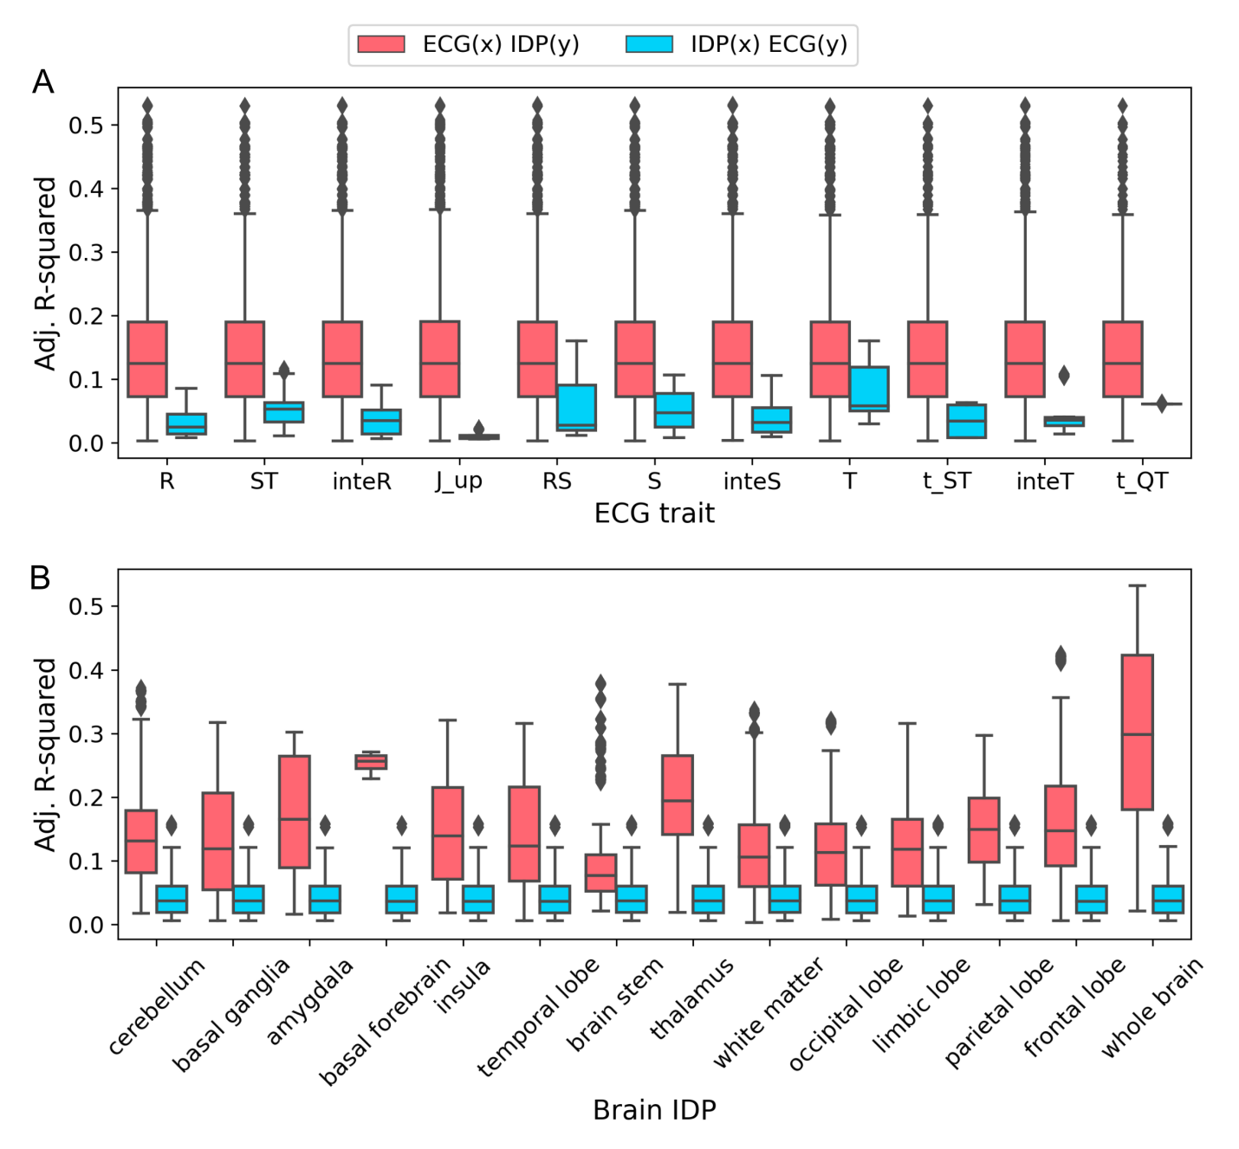

**Supplementary Fig. S4 R-Squared of different types of pairwise regression model**

(A)Boxplot shows the adjustedR Squared of pairwise analysis model based on EGG traits waveform characteristic. (B) Boxplot shows the adjustedR Squared of pairwise analysis model based on brain IDPs neuroanatomical groups. In both panels, red boxes denote models with ECG traits as predictors, while blue boxes represent models with brain IDPs as predictors.

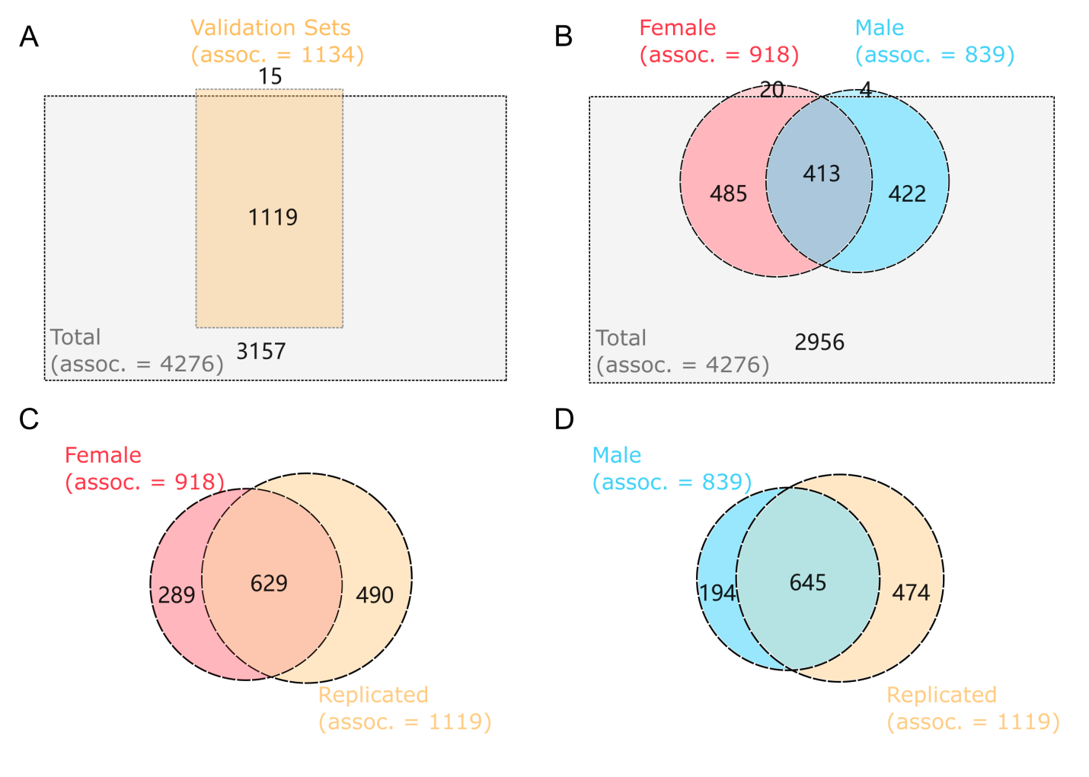

**Supplementary Fig. S5 Phenotypic association of ECG traits and brain IDPs**

(A) Numbers of significant associations between validation cohort and total dataset. (B) Numbers of significant associations across sexes and total dataset. (C) Numbers of significant associations between female cohort and validation set. (D) Numbers of significant associations between male cohort and validation set.

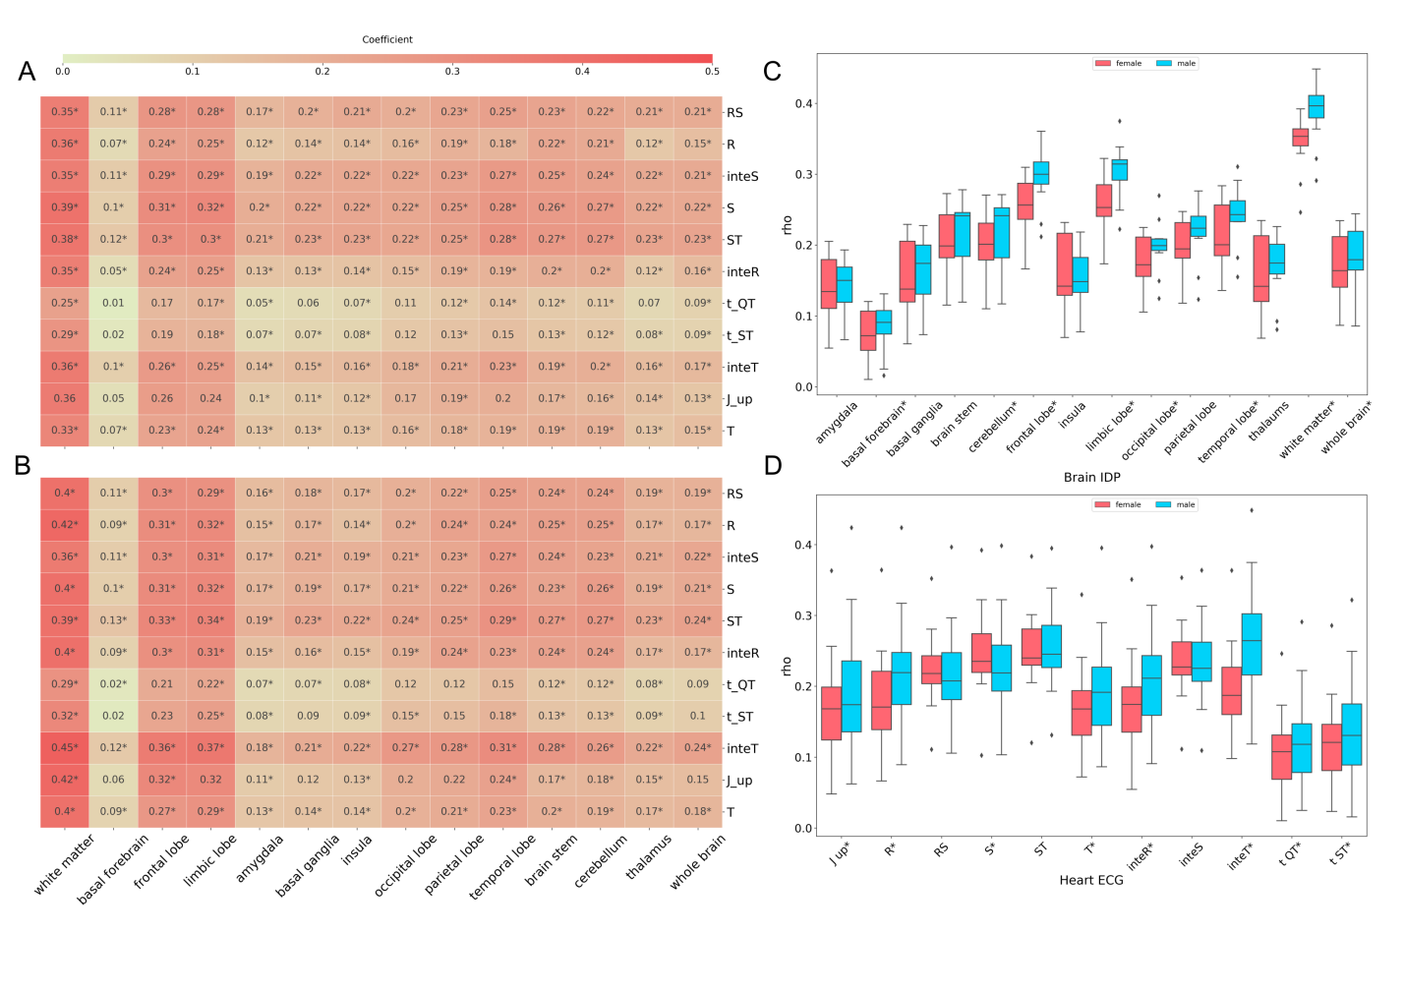

**Supplementary Fig. S6 Canonical correlation analysis for all possible combinations of ECG traits and IDP groups across sexes**

1. Significant correlations between ECG-IDP group pairs identified by canonical correlation analysis (CCA) in females. (B) Significant correlations between ECG-IDP group pairs identified by canonical correlation analysis (CCA) in males. In (A) and (B), cell values represent correlation coefficients, with significant CCA components (P < 0.05) denoted by asterisks. (C) Boxplot shows canonical correlation coefficient (rho) based on brain IDPs neuroanatomical groups across sexes. (D) Boxplot for canonical correlation coefficient (rho) based on ECG waveform characteristic across sexes. In (C) and (D), red boxes denote female, while blue boxes represent male. Traits exhibited statistically significant sex differences in the t-test (p < 0.05) were marked with star (*).

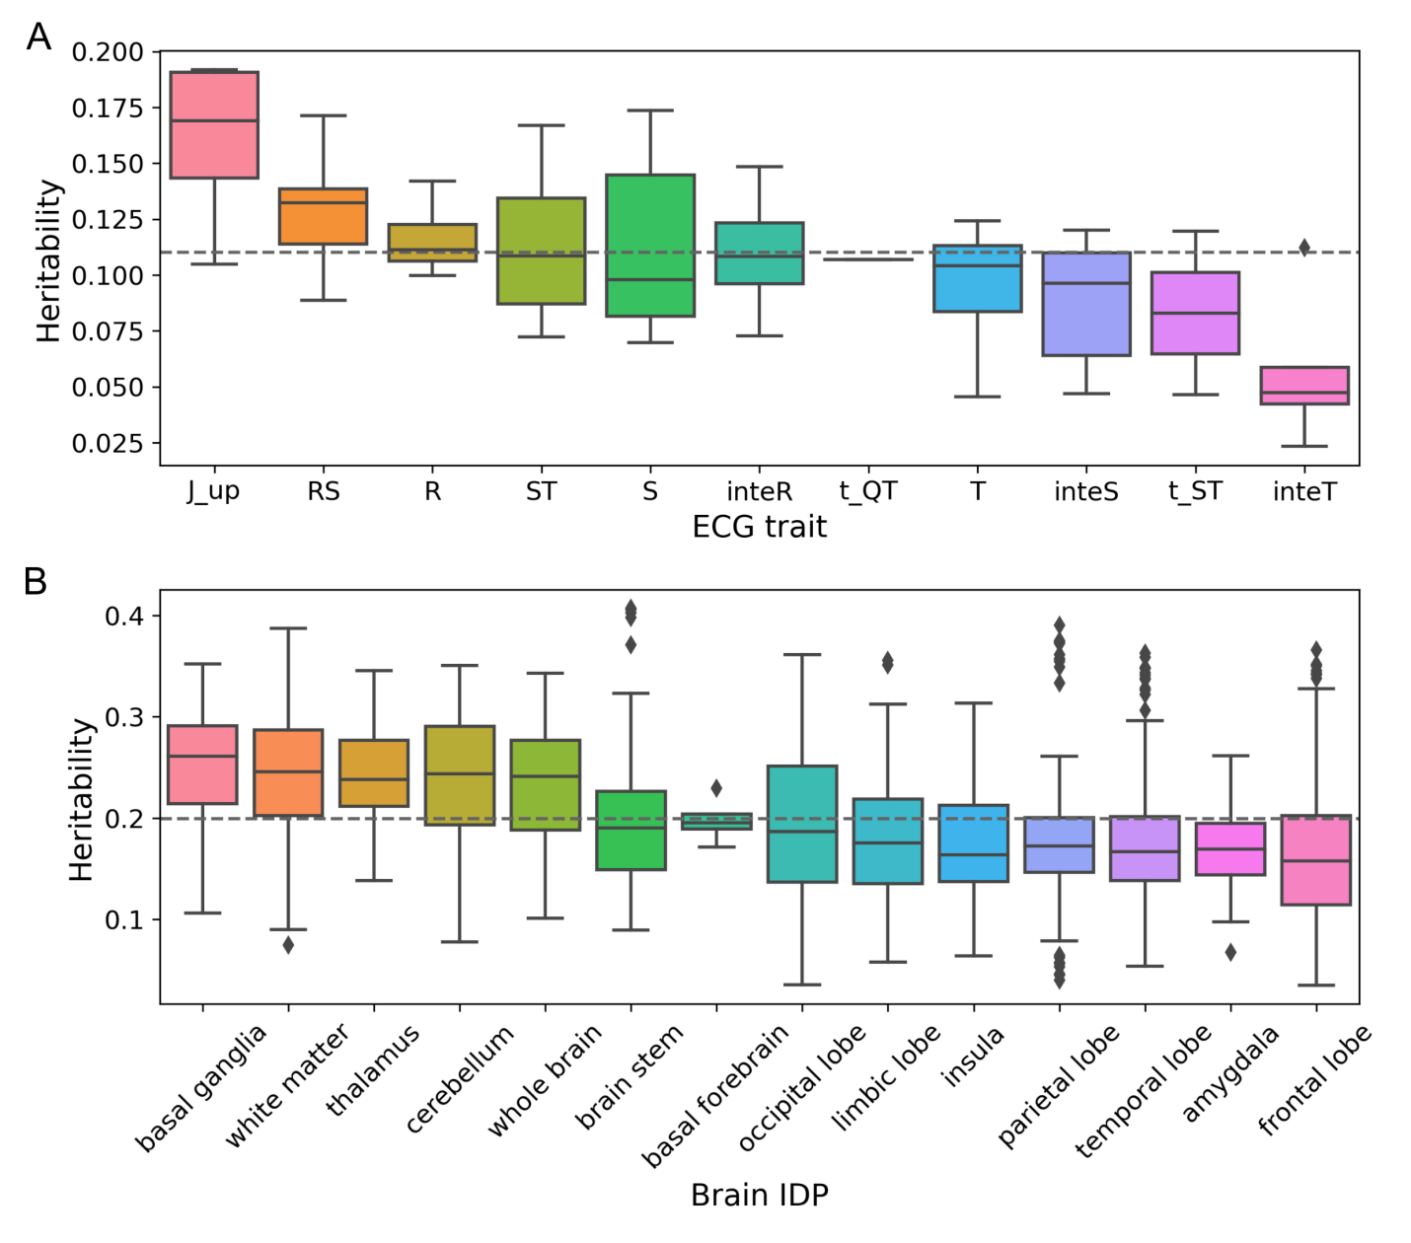

**Supplementary Fig. S7 Heritability of ECG traits and brain IDPs**

1. Boxplot illustrated the heritability of ECG traits across different waveform characteristic types, with an overall mean *hg* of 0.1102. (B) Boxplot illustrated the heritability of brain IDPs categorized by neuroanatomical groups, with an overall mean *hg* of 0.1991. In both panels, the dashed lines indicated the mean value of H2, and x-axis labels were sorted by the mean *hg* of each box.

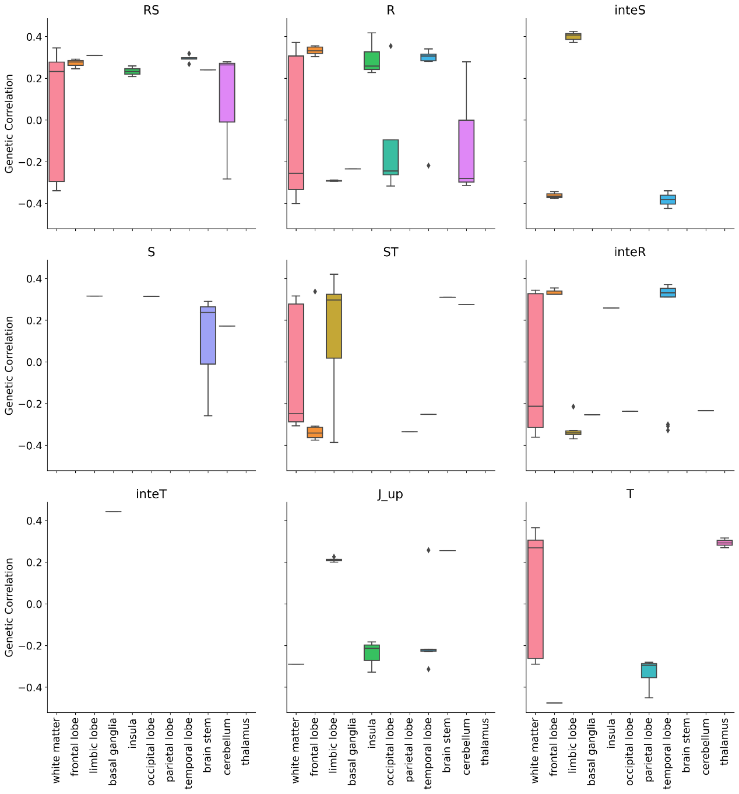

**Supplementary Fig. S8 Genetic Correlation reported by cross-trait LDSC for all significant associations**

Boxplots show the genetic correlation (*rg*) between different ECG-IDP group pairs

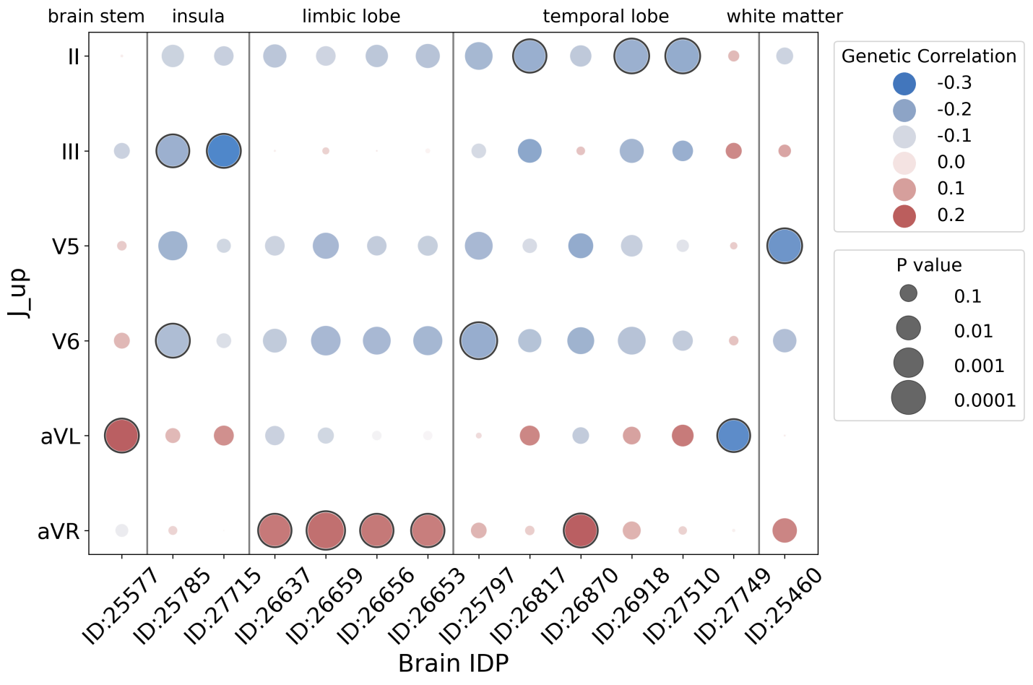

**Supplementary Fig. S9 Genetic associations of voltage difference between R-wave-start and S-wave-end (J_up)**. Each dot represents a genetic association, with color intensity reflecting the genetic correlation strength, and dot size proportional to the log value of P-value. Bonferroni-corrected significant associations (*P* < 5.26×10-4) are encircled.

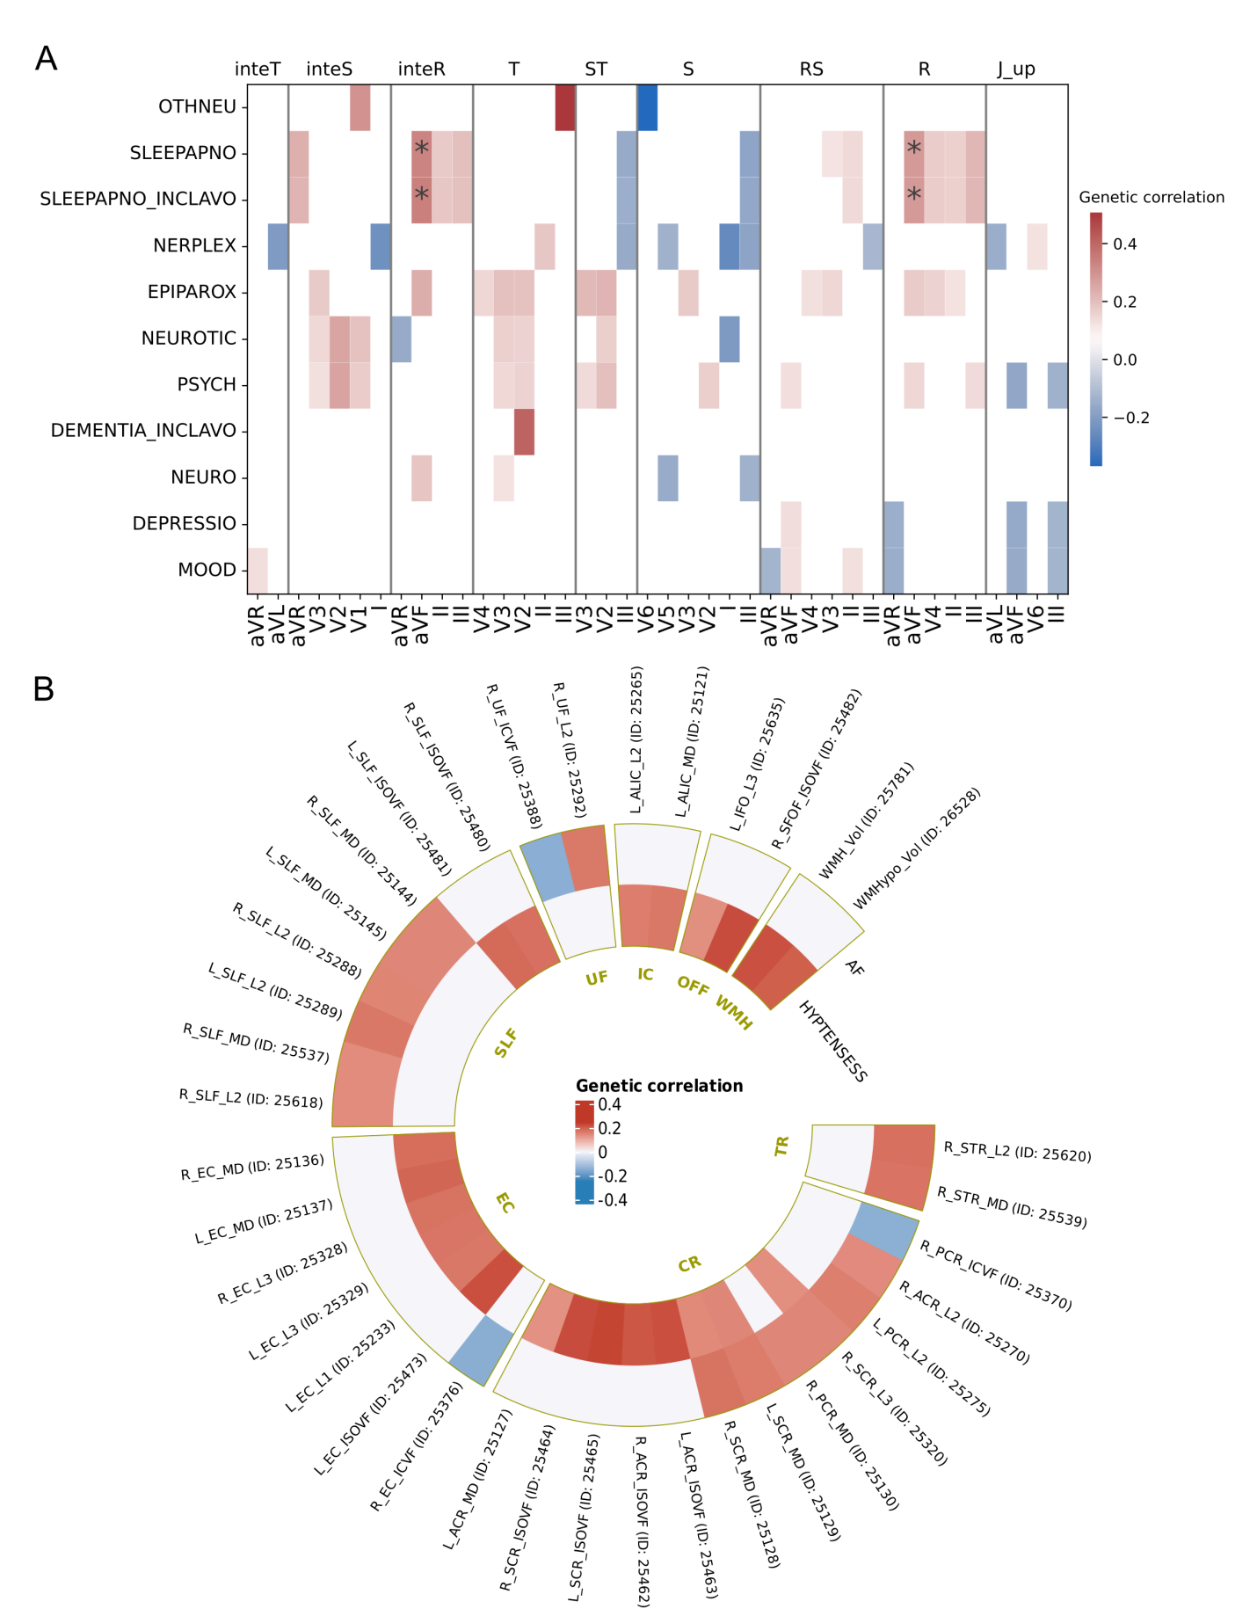

**Supplementary Fig. S10 Genetic correlation of ECG traits–brain disease, and brain IDPs-heart disease**

(A) Nominal significance (*P* < 0.05) association between ECG traits and brain related disease. The color of each patch reflects the genetic correlation strength, and Bonferroni-corrected significant associations (P < 5.26×10-4) were marked with asterisk. OTHNEU: Other neurological diseases; SLEEPANPNO: Sleep apnoea; SLEEPAPNO_INCLAVO: Sleep apnoea, including avohilmo; NERPLEX: Nerve, nerve root and plexus disorders; EPIPAROX: Episodal and paroxysmal disorders; NEUROTIC: Neurotic, stress-related and somatoform disorders; PSYCH: Psychiatric diseases; DEMENTIA_INCLAVO: Dementia, including avohilmo; NEURO: Neurological diseases; DEPRESSIO: Depression; MOOD: Mood [affective] disorders. (B) Bonferroni-corrected significant associations (*P* < 2.39×10-5) between brain IDPs (labeled with their UKB ID) and heart-related diseases. The color of each patch reflects the genetic correlation strength. AF: Atrial fibrillation and flutter; HYPTENSESS:Hypertension, essential; TR: CR: corona radiata; EC: external capsule; IC: internal capsule; OFF: occipitofrontal fasciculus; SLF: superior longitudinal fasciculus; UF: uncinate fasciculus; WMH: white matter hypointensities.

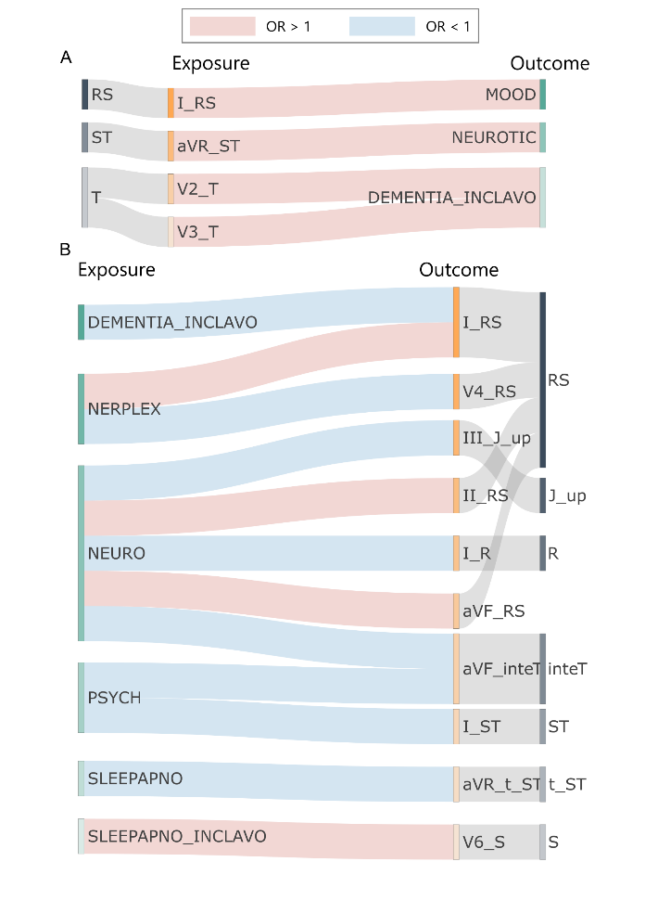

**Supplementary Fig. S11 Causalities between ECG traits and brain disorders**

(A) Robust causal relationships obtained from forward MR analyses with ECG traits as exposures and diseases as outcomes. (B) Robust causal relationships obtained from reverse MR analyses with ECG traits as outcomes and diseases as exposures. In both panels, the red line represents a risky causal relationship, and the blue line indicates a protective causal relationship. MOOD: Mood [affective] disorders; NEUROTIC: Neurotic, stress-related and somatoform disorders; DEMENTIA_INCLAVO: Dementia, including avohilmo; NERPLEX: Nerve, nerve root and plexus disorders; NEURO: Neurological diseases; PSYCH: Psychiatric diseases; SLEEPANPNO: Sleep apnoea; SLEEPAPNO_INCLAVO: Sleep apnoea, including avohilmo.

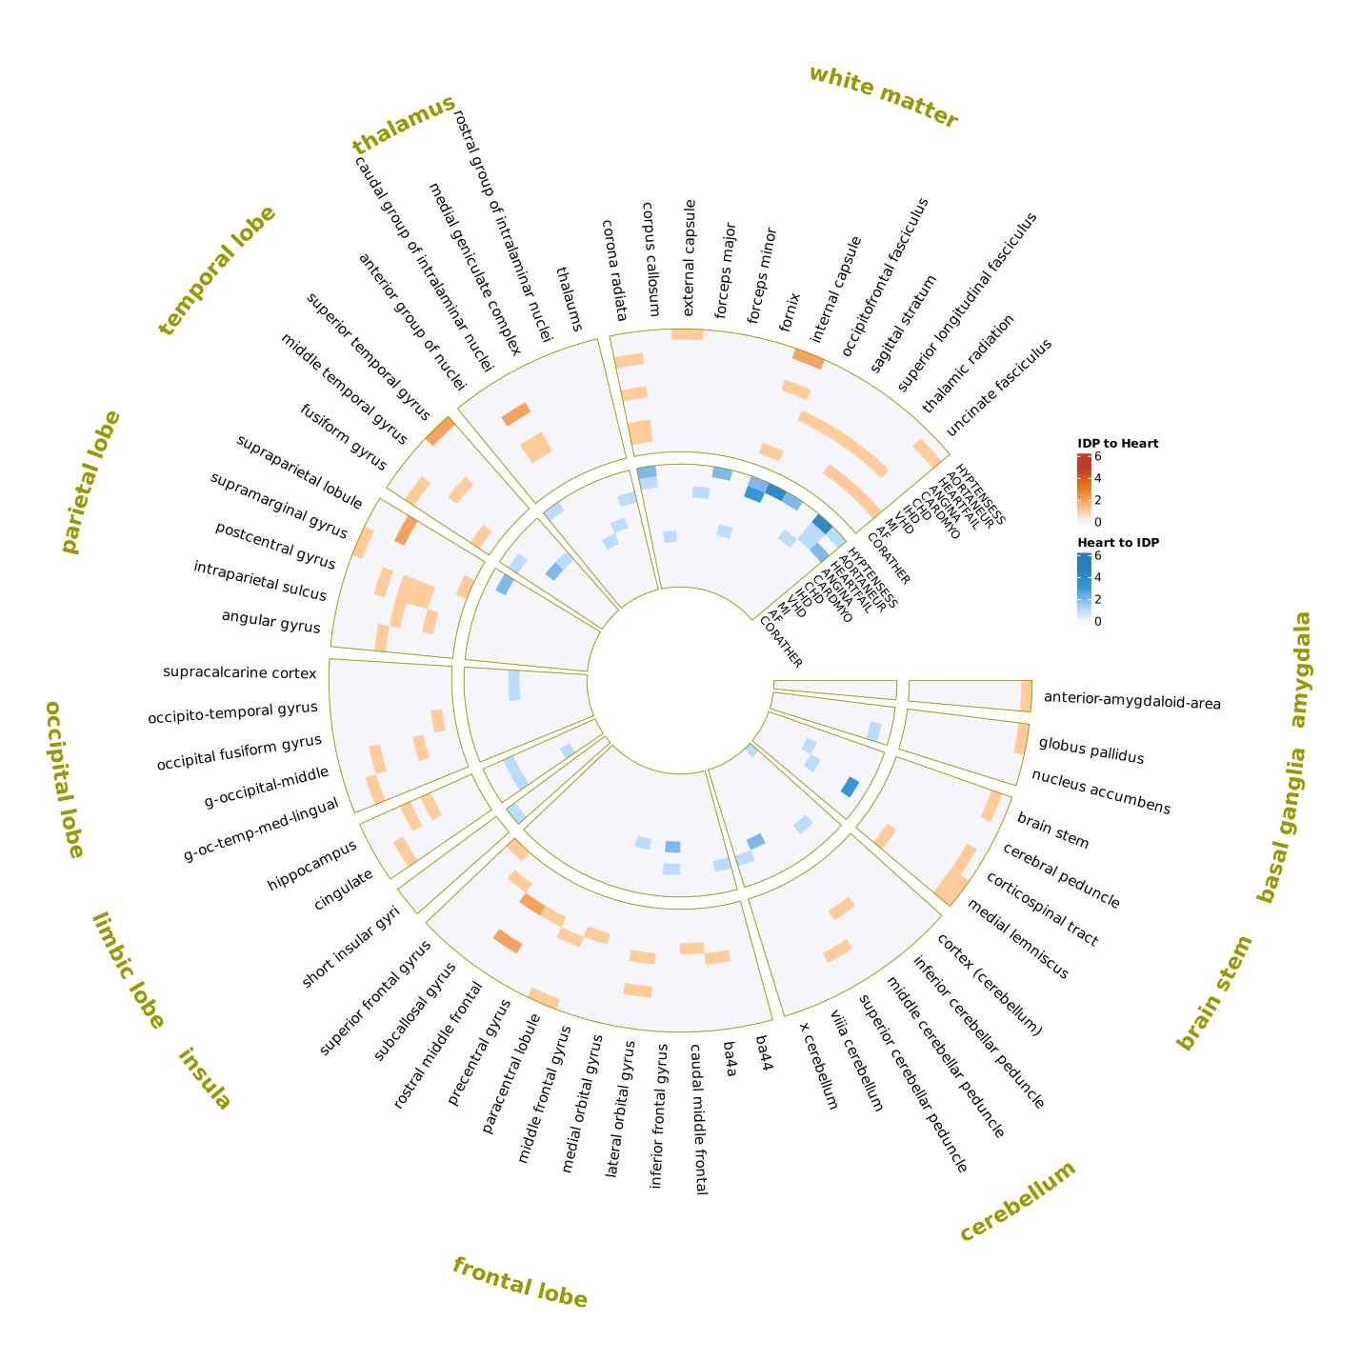

**Supplementary Fig. S12 Summary of causal associations between brain IDPs and heart-related disease**

This circular heatmap depicts bidirectional MR findings between brain IDPs and heat-related diseases. The outer ring displays forward MR results (brain IDPs as exposures affecting disease outcomes), while the inner ring shows reverse MR associations (diseases as exposures influencing brain IDPs). Each ring contains nine tracks representing heart-related diseases, with brain IDPs categorized into 12 distinct sectors based on neuroanatomical regions. Color intensity in each cell corresponds to the number of significant associations between specific brain subregions and heart-related disorders. AF: Atrial fibrillation and flutter; ANGINA: Angina pectoris; AORTANEUR: Aortic aneurysm; CARDMYO: Cardiomyopathy; CHD: Major coronary heart disease event; CORATHER: Coronary atherosclerosis; HEARTFAIL_ALLCAUSE: All-cause heart failure; HYPTENSESS: Hypertension; IHD: Ischaemic heart disease; MI_STRICT: Myocardial infarction, strict; VHD: Valvular heart disease.

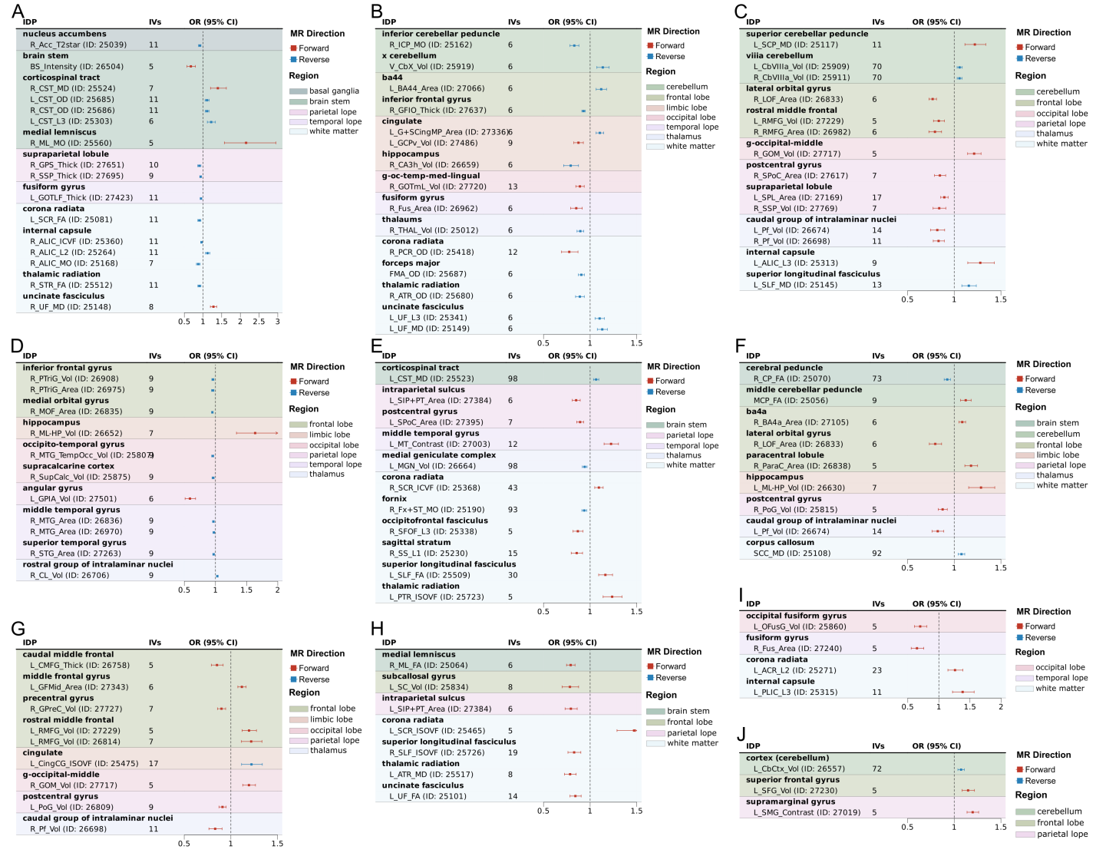

**Supplementary Fig. S13 Forest plot for causalities between brain IDP and cardiovascular disease**

(A)Aortic aneurysm. (B) All-cause Heart Failure. (C) Angina pectoris. (D) Cardiomyopathy. (E) Major coronary heart disease event. (F) Ischaemic heart disease. (G) Valvular heart disease. (H) Myocardial infarction. (I) Atrial fibrillation and flutter. (J) Coronary atherosclerosis. In all panels, robust associations obtained from forward MR analyses (with brain IDPs as exposures and diseases as outcomes) are shown in red, while associations from reverse MR analyses (with brain IDPs as outcomes and diseases as exposures) are displayed in blue. Distinct background colors represent IDPs originating from different brain regions.

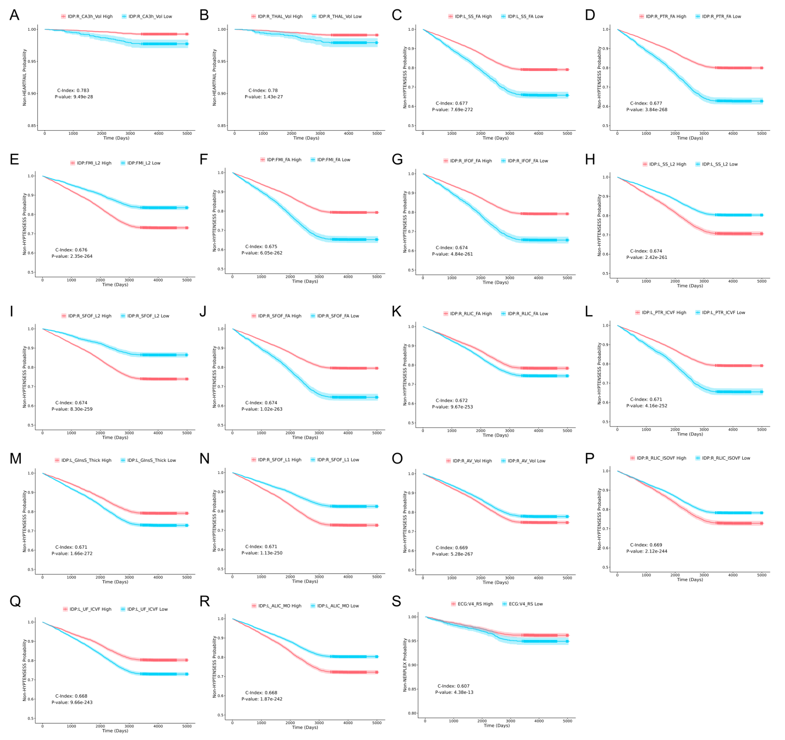

**Supplementary Fig. S14 The Kaplan-Meier survival curves illustrating the disease risk stratification by MR- and Cox- validated traits**

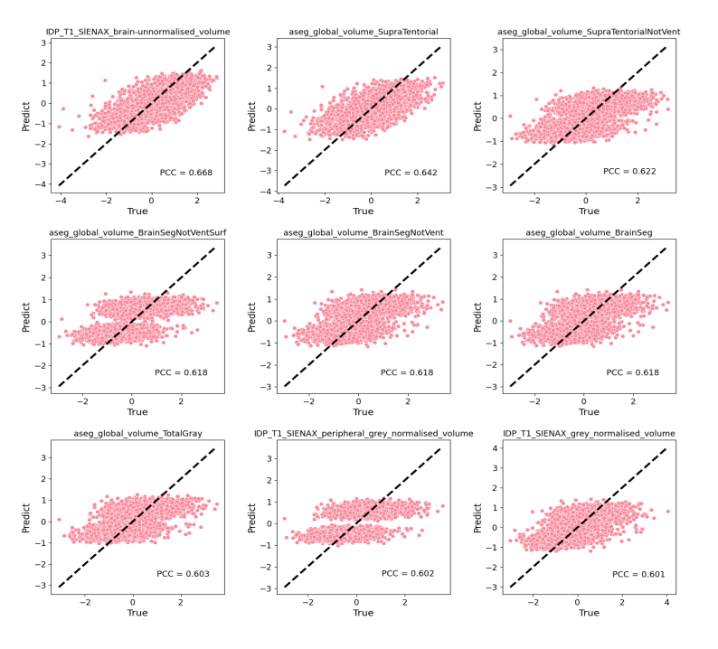

**Supplementary Fig. 15 The Pearson correlation coefficient of the predicted IDPs and the observed IDPs (PCC > 0.6)**